**Practical: 01**

**AIM: Use Cramer’s rule to solve the following 2×2 system of linear equations for x and y:**

**ax+by=e**

**cx+dy=f**

**x=(ed-bf)/(ad-bc)**

**y=(af-ec)/(ad-bc)**

**Write a Java program that prompts the user to enter the constants a, b, c, d, e and f and display the solution (x=?? and y=??). If ad-bc is 0, then your program prints “The equation has no solution”.**

**INPUT**

import java.util.Scanner;

public class practical1

{

public static void main(String[]args)

{

float a,b,c,d,e,f,p;

Scanner sc=new Scanner(System.in);

System.out.println("ENTER THE VALUES FOR EQUATION 1 : ");

System.out.println("e = ax + by");

System.out.println("Enter the value of 'a' : ");

a=sc.nextFloat();

System.out.println("Enter the value of 'b' : ");

b=sc.nextFloat();

System.out.println("Enter the value of 'e' : ");

e=sc.nextFloat();

System.out.println("ENTER THE VALUES FOR EQUATION 2 : ");

System.out.println("f = cx + dy");

System.out.println("Enter the value of 'c' : ");

c=sc.nextFloat();

System.out.println("Enter the value of 'd' : ");

d=sc.nextFloat();

System.out.println("Enter the value of 'f' : ");

f=sc.nextFloat();

System.out.println("EQUATIONS YOU ENTERED ARE : ");

System.out.println(+e+" = "+a+"x + "+b+"y");

System.out.println(+f+" = "+c+"x + "+d+"y");

p=((a*d)-(b*c));

if (p!=0)

{

System.out.println("SOLUTION:- ");

double x=(((e*d)-(b*f))/((a*d)-(b*c)));

System.out.println("x = "+x);

double y=(((a*f)-(e*c))/((a*d)-(b*c)));

System.out.println("y = "+y);

}

else

{

System.out.println("This equation has no solution !!!");

}

}

}

**OUTPUT**

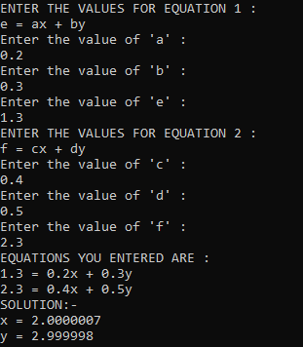

**Figure: 01**